Used Book Store
by
Qahtan
A Thesis Submitted in
(Partial) Fulfillment of the
Requirements for the Degree
of
Bachelor of Science in
Information & Communication Technology
at
Bahrain Polytechnic
Dec 2025

Title


Copyright

All rights reserved
By Qahtan
@ 2025

Declaration I hereby declare that this submission is my own work and that, to the best of my knowledge and belief, it contains no material previously published or written by another person nor material which to a substantial extent has been accepted for the award of any other degree or diploma of the university or other institute of higher learning, except where due acknowledgment has been made in the text.
Qahtan signature / Qahtan
date 15th Nov 2025

Approval Signatures
APPROVED FOR THE ICT PROGRAMME
________________________________________________ (thesis supervisor), Thesis Supervisor ________________________________________________ (writing tutor), Date Technical Writing Tutor Date Approval Signatures
APPROVED FOR THE ICT PROGRAMME
________________________________________________ (thesis supervisor), Thesis
Supervisor ________________________________________________ (writing tutor), Date
Technical Writing Tutor Date

Abstract
The presented project is about the design and development of a web-based platform for Used Book Store which is a digital community market for the Bahrain Polytechnic. In light of the continuous problems faced by students in obtaining affordable academic books i.e. high prices, limited availability, and lack of a single exchange system, the platform offers a reliable, digital marketplace based on roles for the trade of used textbooks. The whole idea is to make it easier for people, earth-friendly, and to get the community together with an efficient and user-friendly solution. The system utilizes a modern tech stack with React for frontend and Supabase (Postgres, Auth, and Storage) for backend. The main features include secure login, CRUD operations for book listings, real-time messaging between consumers and sellers, and thorough search and filtering tools. Role-based access control guarantees that students, professors, and administrators will have shaded access to the system according to permissions laid out beforehand, thus enhancing both security and reliability. The administrators will have such tools like listing moderation, user management, and audit logs which will support them in oversight and will create a trustworthy atmosphere for the academia. The development process was guided by a well-structured methodology which included stakeholder interviews, requirements gathering, and iterative prototyping in its initial phase. The use of Agile development cycles enabled getting feedback and refining the tree continuously. The system was put through a series of tests which included functional, integration, usability, security, and acceptance testing to measure performance, user experience, and stability of the system under various scenarios. The results were positive and indicated that all essential functions were working properly, and the interface was user-friendly and accessible to every user role.

Acknowledgements
First and foremost, I would like to express my deepest gratitude to my supervisor, Mr. Husain Alzain, for his continuous support, guidance, and constructive feedback throughout the entire development of this thesis project. His expertise and encouragement were invaluable in helping me stay focused, motivated, and committed to delivering a high-quality outcome.
I would also like to extend my sincere appreciation for his academic insight, thoughtful suggestions, and ongoing support during the thesis process. His guidance greatly contributed to refining the direction and clarity of my work.
My heartfelt thanks go to Bahrain Polytechnic for providing the opportunity, resources, and environment that enabled this project to be successfully completed. I am especially grateful to the faculty and staff who consistently offered assistance and feedback throughout my academic journey.
I would also like to thank all the students and participants who contributed their time during the requirements gathering and testing phases. Their input and feedback were essential in shaping the functionality and usability of the Used Book Store system.
A special note of appreciation goes to my colleague Hasan for his collaboration, dedication, and continuous support during this project. His teamwork and shared commitment made this experience both productive and enjoyable.
Finally, I would like to express my utmost gratitude to my family and friends for their unwavering encouragement, patience, and motivation. Their support, especially during the most challenging stages, played a significant role in helping me complete this thesis.

Table of Contents
Abstract 6
Acknowledgements 7
List of Abbreviations 12
1. Introduction 14
1.1. Project Rationale 14
1.2. Project Objectives 14
1.2.1. Technical Objectives 14
1.2.2. Business Objectives 14
1.3. Prior Work 15
1.4. Hypothesis 15
1.5. Suggested Resolution 15
1.6. Description of the Report 15
2. Background 16
2.1. Related Theory and Literature 16
2.1.1. Digital Marketplaces 16
2.1.2. Sustainability and Resource Sharing 16
2.1.3. E-Commerce and Role-Based Access Control (RBAC) 17
2.2. Project Technology 17
2.3. Related Work 20
2.4. Market Demand and User Needs 20
2.5. Educational Impact 21
2.6. Challenges and Issues 21
3. Methodology 22
3.1. System Analysis and Requirements Gathering 22
3.2. Design Approach 22
3.2.1. Use Case Diagram 22
3.2.2. Prototyping 23
3.3. Data Structure and Database Design 32
3.4. Activity and Sequence Diagrams 33
3.5. Technology Stack and Justification 36
3.6. Security and Privacy Considerations 37
3.7. Development Process 37
3.8. Summary 37
4. Implementation 38
4.1. Development Stack and Tools: 38
4.2. Environment and System Setup: 39
4.2.1. Supabase Project Configuration 39
4.2.2. Database Schema Design 40
4.2.3. Supabase Auth Setup 42
4.3. Front-End Implementation 42
4.4. Backend, Database & Business Logic (Supabase) 44
4.5. Secure In-Platform Messaging 45
4.6. Administrative Features and Monitoring 46
5. Testing 47
5.1. Test Plan 47
5.2. Participants 48
5.3. Functionality Test Cases & Results 49
5.4. Acceptance Tests Process & Results 50
5.5. Usability Testing Results & Statistics 51
6. Discussion, LESPI, and Conclusion 52
6.1. System Functionality 52
6.2. Summary of Achieved Objectives 53
6.3. Project Issues 54
6.4. Future Work 55
6.5. Synopsis of Experience 55
6.6. Institutional Perspective 56
6.7. Legal, Ethical, Social, and Professional Issues (LESPI) 56
6.7.1. Legal 56
6.7.2. Ethical 57
6.7.3. Social 57
6.7.4. Professional 58
6.8. Conclusion 59
References 59
Appendices 61

Table of Figures
Figure 1 Use case diagram 23
Figure 2 Login Screen 24
Figure 3 Authentication Screen 25
Figure 4 Dashboard 26
Figure 5 Upload Book 27
Figure 6 Tempelate Selection 28
Figure 7 Audit by Admin 29
Figure 8 Sales Chart for Admin 30
Figure 9 Book Request 31
Figure 10 Sales Audits 32
Figure 11 Database Design 33
Figure 12 Activity Diagram 34
Figure 13 Explanation of symbols used in Diagram 35
Figure 14 Sequence Diagram 36

List of Abbreviations

Table of Abbreviations
Abbreviation | Full Term | Description
ICT | Information and Communication Technology | Field of study related to computing and digital systems
RBAC | Role-Based Access Control | Security method assigning permissions based on user roles
CRUD | Create, Read, Update, Delete | Core operations used in database and application development
UI | User Interface | Visual elements through which users interact with the system
UX | User Experience | Overall user interaction and satisfaction with the system
SQL | Structured Query Language | Language used to manage and query relational databases
ERD | Entity-Relationship Diagram | Diagram showing database structure and relationships
API | Application Programming Interface | Interface enabling communication between software systems
RLS | Row-Level Security | Database feature controlling record-level access
DB | Database | Organized system for storing and managing data
QA | Quality Assurance | Testing and validation processes to ensure system quality
UAT | User Acceptance Testing | Final testing phase conducted by end users
IDE | Integrated Development Environment | Software used for coding and development
SPAs | Single-Page Applications | Web apps loading content dynamically without reloading pages
GDPR | General Data Protection Regulation | Data privacy regulation (used when discussing legal aspects)
MVP | Minimum Viable Product | Early version containing essential features
DOM | Document Object Model | Browser representation of a webpage used by JavaScript
CSS | Cascading Style Sheets | Styling language for websites

Introduction

Project Rationale
Polytechnic students have to face a lot of difficulties due to the high price and limited availability of academic textbooks, which greatly impacts their access to crucial learning materials. These challenges are worsened by the absence of a unified marketplace for the students to exchange the old books among themselves. One of the project's goals is to close that divide by creating a secured online Used Book Store platform that is based on roles and focuses specifically on the accessibility of textbooks problem and the resource sharing of sustainable nature among the students.

Project Objectives

Technical Objectives
- Create a user-friendly, web-based platform that allows administrators, teachers, and students to authenticate and be authorized based on their roles.
- Entries by implementing CRUD operations for book listings.
- To help buyers and sellers communicate, enable secure in-platform messaging.
- Use search and filter functions to find books quickly and effectively.
- Offer an administrative interface for tracking user activity and listings.

Business Objectives
- Give Polytechnic students a convenient and reasonably priced way to get academic textbooks.
- Academic community to reuse books in order to promote sustainability.
- Establish a reliable and safe marketplace that is solely centered on the Polytechnic ecosystem.
- Improve community involvement and student collaboration on the platform. Provide a scalable solution that can be added to other institutions or expanded with new features.

Prior Work
Although there are several international marketplaces for textbooks and general used goods, none are designed with Polytechnic students' needs in mind, with role-based controls and an emphasis on local academic communities. Current platforms frequently lack the community-specific features, security, and usability necessary to promote engagement and trust between instructors and students. By adapting the solution to institutional requirements and incorporating features that efficiently support the academic user base, this project expands on these insights.

Hypothesis
Academic textbooks will become more affordable and accessible, promoting a collaborative and sustainable learning environment, if a specialized platform for the Used Book Store is created that provides Polytechnic staff and students with safe, role-based access and community-specific features.

Suggested Resolution
With React frontend development, the project will produce a web application built on Supabase. The system will enable a messaging system for buyer-seller communication, safe login for various user roles, and effective CRUD operations for managing book listings. In addition to administrative features for security and oversight, the platform will have search and filtering features for user convenience. This solution seeks to improve the Polytechnic community's experience exchanging textbooks, lower expenses, and encourage sustainability.

Description of the Report
The development lifecycle of the Used Book Store project is described in detail in this thesis document. It starts with the goals and justification for the project, then moves on to the system architecture and design, implementation specifics, testing procedures, and outcome assessment. The document offers a thorough summary of the project deliverables and results and also addresses risk assessment, quality management techniques, and future work considerations.

Background

Related Theory and Literature
The Used Book Store project is based on a combination of theories and practical aspects that pertain to digital marketplaces, resource sharing, sustainability, and e-commerce platforms for academia, among others. Grasping these fundamentals is a prerequisite for understanding the design decisions and the technology employed in the project.

Digital Marketplaces
Digital marketplaces act as conduits for the virtual exchange of goods and services between users. They are the step forward of mankind in the commercial marketplace, as they have allowed us to reach wider markets, increase efficiency, and lower the costs involved in transactions. Amazon, eBay, and other similar online stores that concentrate on specific types of customers. In the setting of academic resource sharing these places concentrate on providing the exchange of textbooks and study materials that is accessible, affordable, and prompt, a critical situation considering the high costs of new academic books.

Sustainability and Resource Sharing
The current state of the world, both environmental and economic, is giving a big push for sustainability in all aspects of consumption. Resource-sharing practices such as renting, exchanging, and selling used items usher in a new era of minimal waste and cutting down on the demand for new production. The Used Book Store supports the exchange of books among students, thus, saving the resources as well as money. This practice is in line with the circular economy and environmentalist consumer behavior trends.

E-Commerce and Role-Based Access Control (RBAC)
The secure and properly functioning online stores rely on the role-based access control system that allows the distinction between different user groups and the enforcement of corresponding permissions. RBAC increases the security of data, the privacy of users, and the integrity of the platform by managing to give access to only those resources and features that are needed for every role to buyers, sellers, administrators, and all other parties involved. It is a very important thing for academic platforms where delicate details like user identity, academic connections, and transaction information are processed.

Project Technology
The project implements a modern web application stack based on secure, scalable, and efficient technologies which give way to a smooth textbook exchange experience.
- Front-end Framework: React.js is the front-end choice with its component-based architecture, making it possible to create dynamic, responsive, and interactive user interfaces for various user roles.
- Backend Infrastructure: Node.js and Express.js form a strong server-side environment that can manage asynchronous requests, user authentication, and data handling.
- Database: A SQL database like supabase is picked for its adaptable schema and the ability to grow, which is ideal for changing platform needs and various data types such as user profiles, listings, and transactions.
- Authentication and Security: Secure access and data protection are guaranteed by role-based login systems and encryption libraries.
- Communication: Integrated messaging facilitates direct and real-time communication between buyers and sellers.
- Search and Filtering: Effective algorithms aid users in finding books by title, author, subject, or condition.

Technology | Purpose
React.js  | React.js is a component-based JavaScript library used to build fast, interactive, and responsive user interfaces. In the Used Book Store system, React manages the entire front-end architecture, rendering different pages for Students, Teachers, and Admins based on their roles. Its modular structure supports reusable UI components, improves maintainability, and enhances performance, especially in single-page applications (SPA).
Node.js  | Node.js is a server-side JavaScript runtime that supports asynchronous, event-driven programming. In this project, it handles backend logic, API routing (when needed), and communication with Supabase. Its lightweight and scalable nature makes it suitable for real-time features such as messaging and system notifications.
Express.js  | Express.js is a minimal web framework for building backend services. In the Used Book Store project, it is used to manage RESTful API endpoints, middleware, user validation, and secure communication between the frontend and Supabase backend. Its simplicity helps streamline development.
Supabase (Postgres, Auth, Storage)   | Supabase serves as the main backend platform, handling authentication, database storage, and file uploads. Supabase Auth secures role-based login; Postgres stores users, listings, and messages; Storage handles book images; and RLS (Row-Level Security) enforces strict access control. Supabase provides real-time updates for messaging and listing changes.
Tool | Purpose
Figma  | Figma is an online UI/UX design tool used to create wireframes, prototypes, and responsive layouts. For the Used Book Store, it helped design user-centric screens such as login pages, dashboards, and book management workflows across multiple device sizes.

Library / API | Purpose
Axios | Axios is a promise-based HTTP client used to make secure API requests from the frontend. It handles communication with Supabase for authentication, listing management, and messaging.
bcryptjs | bcryptjs is used for hashing and securing password data where needed. In the Used Book Store system, it helps ensure secure user authentication and protects sensitive data.
Supabase JavaScript Client | Enables communication with Supabase services including Auth, Database, and Storage. It manages login, CRUD operations for books, real-time messaging, and file uploads.
Multer (optional if used) | Middleware for handling file uploads. Useful if images are first processed before sending to Supabase Storage.
Tailwind CSS / Bootstrap (whichever you used) | Provides fast, responsive styling for the UI. Tailwind/Bootstrap was used to style dashboards, forms, book cards, and search components without writing extensive CSS manually.
React Router DOM | Enables dynamic routing in the React UI, allowing role-based navigation for Students, Teachers, and Admins. It manages page transitions such as Login → Dashboard → Listings.
Framer Motion (if used) | Used for animations such as transitions, modals, and interactive elements, enhancing the overall user experience.
React Toastify | Provides real-time notifications, showing non-intrusive alerts for actions such as successful login, book listing uploads, updates, or errors.
CORS | Middleware used to enable secure communication between frontend and backend during development.
Morgan (if Express logging used) | Middleware for backend logging of API requests, helping debug issues and monitor server behavior.

Related Work
The general used goods marketplaces are prevalent all over the world, whereas platforms dedicated exclusively to academics and students are rare, especially when it comes to the localized, role-based, and community-centered approach.
On the other hand, Chegg and Amazon’s second-hand books cater to the masses but do not provide the necessary controls or community features to create an atmosphere of trust and convenience in an academic setting.
Moreover, such platforms usually consist of third-party sellers who are neither verified nor do they have any quality control or relevance checks for their textbooks. Literature about peer-to-peer book swapping platforms points out that localized, educational-specific solutions are greatly needed for the market gap by providing curated, role-secured environments that support safe transactions and social interaction among users with similar academic objectives.

Market Demand and User Needs
Textbook affordability is still an obstacle for many students, especially in Polytechnics and similar institutions where the required textbooks' prices eat up a big part of the educational budget. A study on students' buying habits reveals a high preference for second-hand books which are accessible at student friendly prices.
User research suggests that the students are highly concerned about seller verification, user-friendliness, and communication with sellers. The platform's design was based on these needs and thus a digital marketplace was created which combines authentication, quality control, and social interaction, making the acquisition of textbooks a collaborative and cost-saving process.

Educational Impact
By enabling prompt access to the recommended study materials, the platform also plays a major role in uplifting academic experience. It indirectly favours higher academic performance by eliminating material accessibility issues, which are one of the main reasons that slow down the course. On top of that, the project promotes students to be the one who draw the academic community, the one who get the most out of the e-commerce and internet communication skills which are not limited to the book exchanges context but they are valuable elsewhere too.

Challenges and Issues
The project's methodology is informed by several challenges:
- Clear policies and user feedback systems are necessary to guarantee that book listings are genuine, pertinent, and in acceptable condition.
- Robust backend controls and strong authentication are necessary to safeguard user data and stop fraudulent activity.
- Simple workflows, responsive support, and intuitive design are key components in encouraging instructors and students to actively use the platform.
- The system must be able to handle growing user counts and transaction volumes without experiencing a drop in efficiency.
By using secure, modular, and user-friendly solutions, the project's design strategies and technology selections aim to lessen these difficulties.

Methodology

System Analysis and Requirements Gathering
The methodical requirements gathering and stakeholder analysis is a major factor in the success of the Used Book Store project. Initially, stakeholder interviews were held with students, faculty, and university administration to set the agenda for the identification of problems with the purchasing and selling of academic textbooks. The very process consisted of surveys, personal conversations, and the study of current methods used for the university's textbook procurement and peer-to-peer exchanges. The requirements were divided into functional and non-functional ones, respectively, for the functional ones they included the ability for users to post and browse book listings, messaging between buyers and sellers and user authentication, and for the non-functional ones, among them security, scalability, usability, and maintainability, The overall compilation of user stories and use cases was prepared to be used in the next design and prototyping phases.

Design Approach
The system design for the Used Book Store is executed through an iterative and user-centered development model that takes inspiration from the best practices in academic software. The methodology used for the development is Agile spread over sprints for constant feedback from the stakeholders, regular assessment of the prototype, and gradual improvement of both the functionality and the user experience. During this phase, some important artifacts that were developed include:
- Diagrams of use cases showing the interactions between the users and the system
- Entity-relationship diagrams (ERD) which determine data needs.
- User interface mockups that signal page flows and layouts per user role.

Use Case Diagram
There was a case diagram that was made which indicated the three main actor’s admin, teacher, and student and the corresponding interactions with the core system features. The authentication, book posting/listing, messaging, book request/grant actions, and administrative moderation are included among the primary use cases. Thus, the workflow is set according to the role, which at the same time strengthens security and integrity of the data in the system.​
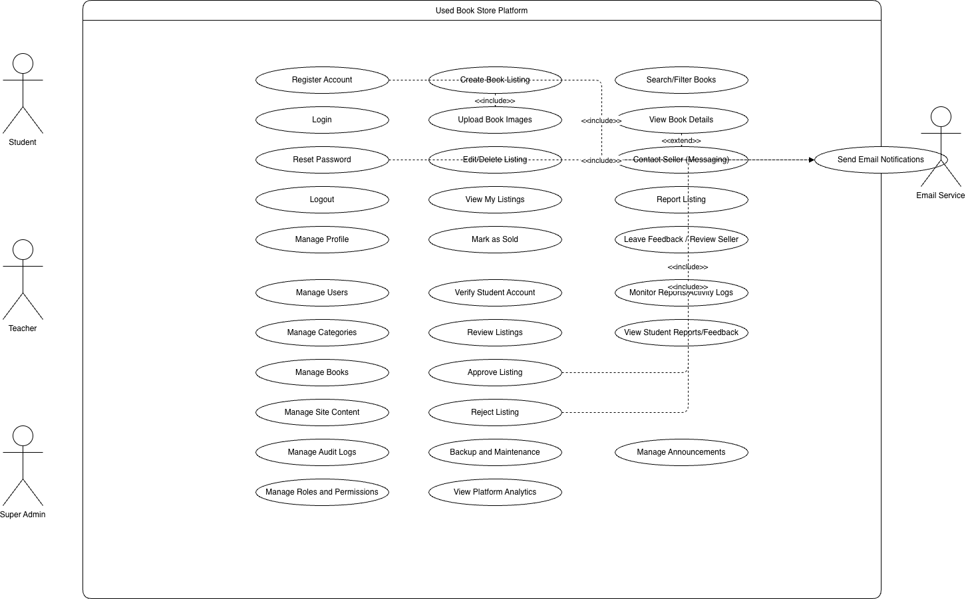
Figure 1 Use case diagram

Prototyping
The initial prototypes were made using Figma and React for quick wireframing and then were presented to the stakeholders for user testing. The feedback cycles in the course of the prototype demonstrations caused refinements in the interface flow, search mechanisms, and the messaging system so that all users can have an easy experience and that also compliance with the accessibility standards is met.​
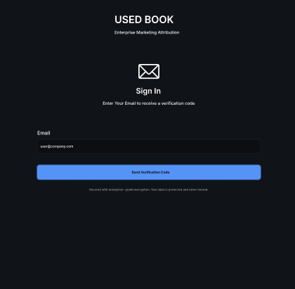
Figure 2 Login Screen
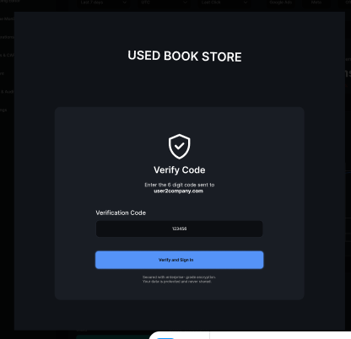
Figure 3 Authentication Screen
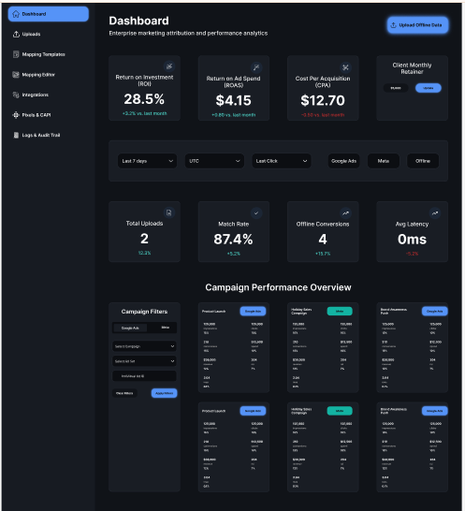
Figure 4 Dashboard
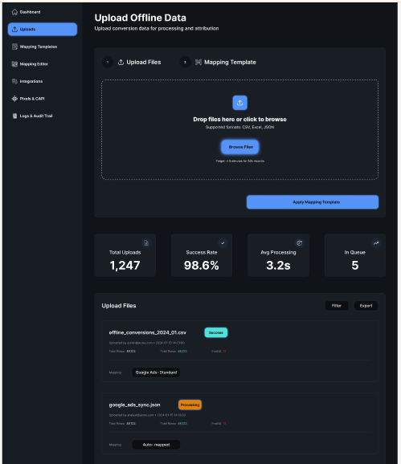
Figure 5 Upload Book
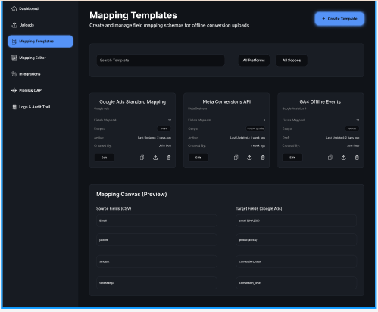
Figure 6 Tempelate Selection
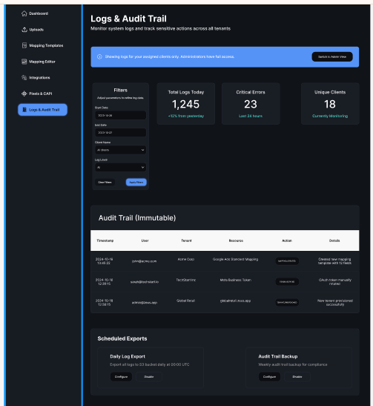
Figure 7 Audit by Admin
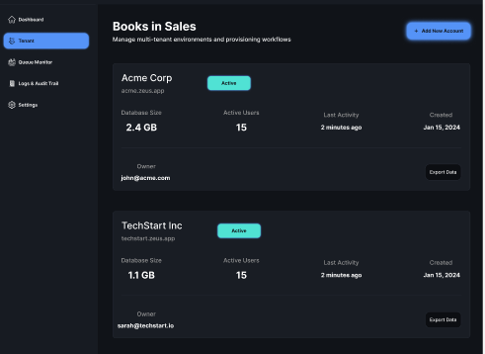
Figure 8 Sales Chart for Admin
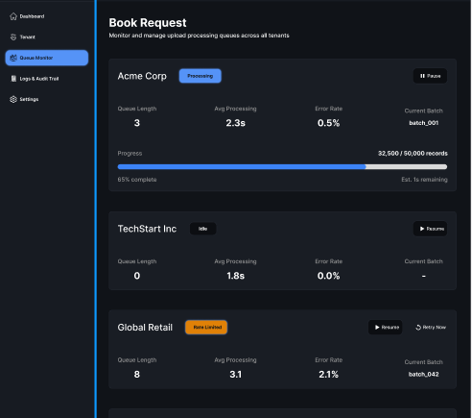
Figure 9 Book Request

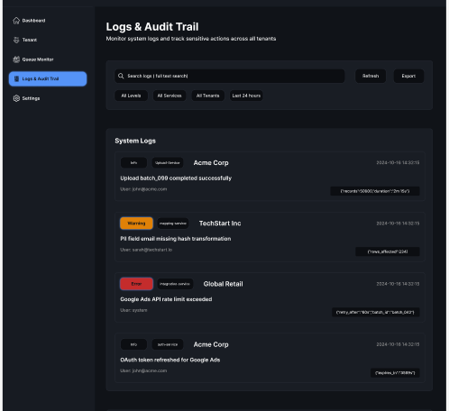
Figure 10 Sales Audits

Data Structure and Database Design
An application housed in Supabase in the cloud is the system database backend which has been chosen for the great performance of its Postgres engine, real-time functionalities, and easy integration with role-based access control. The database design was carried out with the help of ERDs that defined the corresponding tables and records for users, book listings, messages, transaction logs, and administrative actions.
Key considerations in design:
- Normalization to reduce redundancy
- Secure handling of PII (personally identifiable information)
- Indexing for efficient search and filter performance.​
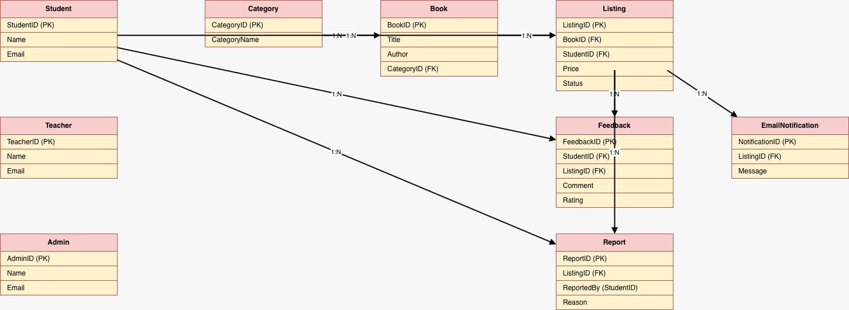
Figure 11 Database Design

Activity and Sequence Diagrams
To make the crucial business logic explicit, Activity and Sequence diagrams were produced. The Activity diagram depicts the entire process from listing a book to booking, negotiating, and finalizing the transaction, including the involvement of the system in the case of disputes. The Sequence diagram shows the flow of messages and notifications between the participants on the platform, which allows updates to be done in real-time and the logic of the whole operation to be confirmed.​
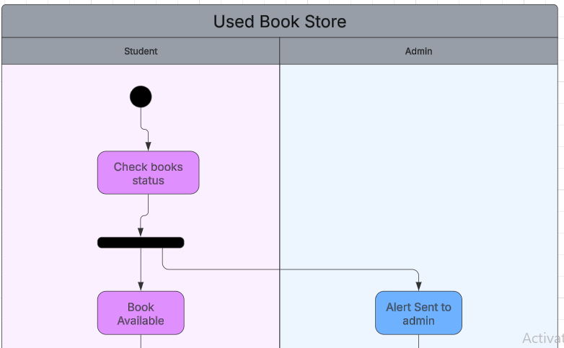
Figure 12 Activity Diagram
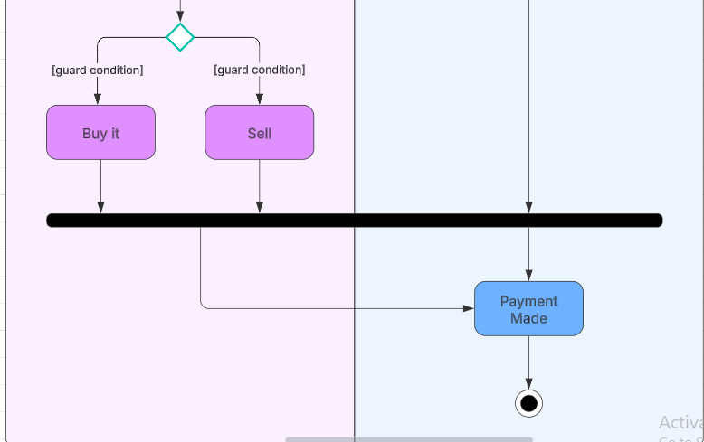
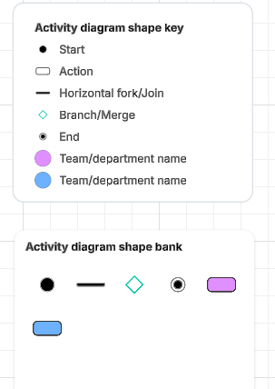
Figure 13 Explanation of symbols used in Diagram
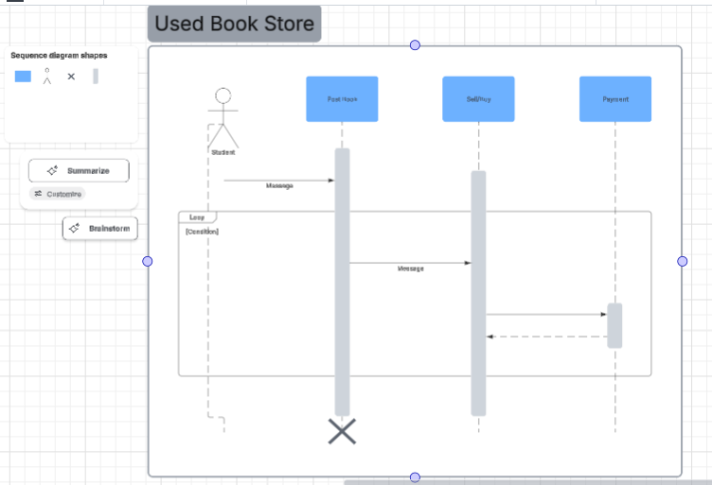
Figure 14 Sequence Diagram

Technology Stack and Justification
At the core of the technology stack are React (for the front end), Supabase/Postgres (for the backend and database), Node.js (for the middleware/API), and libraries for authentication, validation, and communication.
Reasons for Choices:
- React facilitates quick prototyping of interfaces along with modern user expectations of responsive single-page application behavior.
- Supabase allows for smooth integration with powerful authentication and data policies that are necessary for implementing strict role-based controls.
- Node.js acts as middleware giving scalable API endpoints, which is important for platform extensibility and possibly connecting with more campus services in the future.
- Incorporation of supporting tools like ESLint, Prettier, and automated test frameworks (Jest, Cypress) for code quality and reliability.​

Security and Privacy Considerations
A role-based access control system is the main strategy to protect the platform. The permissions are enforced at each API endpoint, and sensitive data is encrypted both at rest and in transit. Security audits are conducted regularly and are part of the deployment pipeline, while the measures for privacy compliance are based on the guidelines for student data protection of both the institution and the country.​

Development Process
The project development was carried out in four major phases:
- Requirement Analysis and Specification: Considering the participation of the stakeholders, requirements were documented, and an initial backlog was created.
- Design and Prototyping: System diagrams, user flows, and data models were created; rapid prototyping and stakeholder reviews.
- Implementation: the Agile sprints delivered iterative functionality, frontend and backend integration, and progressive enhancements based on user feedback.
- Testing and Deployment: The testing before the release consisted of comprehensive functional, integration, and user acceptance testing; the release was done in a campus-controlled environment with post-delivery monitoring for issues.​

Summary
The stepwise methodology in developing the Used Book Store project was presented in this chapter. It was highlighted that user-centered analysis, iterative design, Agile development, secure technology selection, and institutional compliance were the main approaches. All methodological choices were justified in the context of delivering a scalable, secure, and user-friendly platform that meets the specific needs of the Polytechnic community.​

Implementation
This section describes the practical implementation of the Used Book Store web application. It explains how the Supabase-based backend and React frontend were developed, how responsibilities were structured within the project, and how core features such as role-based access, book listings, and secure messaging were integrated into a single, coherent system.
The application supports three primary roles—Admin, Teacher, and Student—and provides a centralized platform where students can list, search, and communicate about used textbooks within the Polytechnic community.

Development Stack and Tools:
The Used Book Store was implemented using the following technology stack (updated from the original proposal to use Supabase and React):
- Backend & Database Layer: Supabase
  - Supabase Postgres Database for storing users, roles, book listings, messages, and logs.
  - Supabase Auth for secure user authentication (email/password) and role handling.
  - Row-Level Security (RLS) policies for authorization and data protection per role.
  - Supabase Realtime / Channels (if enabled) for live updates in message threads and listings.
- Frontend Layer: React
  - React used to build a responsive, component-based single-page application.
  - React Router for client-side routing and role-based page access.
  - A responsive layout using modern CSS (and a CSS framework such as Bootstrap or Tailwind CSS) to ensure usability across desktop, tablet, and mobile devices.
- Core Features Implemented
  - Role-based user authentication and authorization (Admin, Teacher, Student).
  - CRUD functionality for book listings (create, view, update, delete).
  - Secure in-platform messaging between buyers and sellers.
  - Administrative tools for user monitoring, listing moderation, and basic analytics.
  - Final deployment to a cloud platform (e.g., Vercel/Netlify) with Supabase hosting the backend.
  - System documentation (user guide, admin guide, technical documentation) to support maintenance and future enhancements.
Project Proposal (1)
- Development Tools
  - Node.js & npm for managing React dependencies.
  - Visual Studio Code as the main IDE.
  - Git & GitHub for version control and collaborative development.
  - Browser DevTools for debugging UI and API calls.

Environment and System Setup:

Supabase Project Configuration
- Create Supabase Project
  - A new project was created in the Supabase dashboard.
  - The Postgres connection URL, anon key, and service role key were generated and later used in the React frontend’s environment variables.

Database Schema Design
The following core tables were created in Supabase (logical equivalent of the database design in the proposal):
Project Proposal (1)
  - users
    - id (UUID, primary key, linked to Supabase Auth user id)
    - full_name
    - email
    - role (enum: admin, teacher, student)
    - created_at
  - books
    - id (PK)
    - title
    - author
    - course_code / module
    - condition (e.g., New, Like New, Used)
    - price
    - description
    - image_url (stored in Supabase Storage)
    - seller_id (FK → users.id)
    - status (e.g., Active, Sold, Pending Approval)
    - created_at, updated_at
  - messages
    - id (PK)
    - conversation_id (to group messages)
    - sender_id (FK → users.id)
    - receiver_id (FK → users.id)
    - book_id (FK → books.id, optional)
    - content
    - is_read (boolean)
    - created_at
  - audit_logs (for admin monitoring)
    - id
    - user_id
    - action_type (e.g., BOOK_CREATED, BOOK_UPDATED, USER_BLOCKED)
    - details
    - created_at
- Role-Based Security (RLS Policies)
  - RLS was enabled on the books and messages tables.
  - Example policies:
    - Students can insert and update only their own book listings (seller_id = auth.uid()).
    - Teachers/Admins can view all listings and approve or reject them.
    - Messages can only be seen by the sender, receiver, and optionally admins for moderation.

Supabase Auth Setup
  - Email/password sign-up and login were enabled.
  - After registration, the app assigns roles (Admin, Teacher, Student) using a profile record in the users table, ensuring the Supabase Auth user is linked to application-specific data.

Front-End Implementation
The frontend is implemented as a role aware React application with clear separation between public pages, student features, teacher tools, and admin dashboards.
4.3.1 Routing and Navigation
- react-router-dom was used to define routes:
  - Public Routes
    - / – Landing / Home page (overview of the Used Book Store, benefits, and login/register links).
    - /login – Login page.
    - /register – Registration page.
    - /books – Public browse page for viewing available books.
  - Student Routes
    - /my-books – View, create, edit, and delete own book listings.
    - /messages – Messaging inbox for conversations with other users.
    - /profile – Profile management.
  - Teacher Routes
    - /teacher/review-listings – Review and verify student book listings.
    - /teacher/reports – View basic usage/issue reports related to courses.
  - Admin Routes
    - /admin/dashboard – Overview of platform activity (no. of users, active listings, messages).
    - /admin/users – User management (view, block/unblock users).
    - /admin/listings – Full listing moderation (approve, reject, mark as sold).
- Protected Route Components were implemented to:
  - Check the logged-in user’s role from Supabase and profile data.
  - Redirect unauthorized users away from admin/teacher/student-only pages.

4.3.2 Reusable Components
To keep the code modular and maintainable, the following reusable components were created:
- Layout Components
  - Navbar – Displays navigation items according to user role.
  - Footer – Shared across all pages.
- Shared UI Components
  - BookCard – Displays cover, title, price, condition, and seller info.
  - BookList – Reusable listing grid for search results and user-specific pages.
  - SearchBar and filter controls (course, price range, condition, availability).
  - Modal components for confirmation dialogs (e.g., delete listing, mark as sold).
- Messaging Components
  - ConversationList – Displays list of active chats.
  - MessageThread – Shows messages for a selected conversation.
  - MessageInput – Text box for sending new messages.
4.3.3 Responsiveness and UI Behavior
- A mobile-first approach ensured that:
  - Book cards stack vertically on small screens and appear in a grid on larger screens.
  - Navigation collapses into a hamburger menu on mobile.
  - Forms are optimized for touch input as well as desktop use.
- Basic UX enhancements were added:
  - Toast notifications for success/failure (e.g., “Book listing created successfully”).
  - Loading spinners while fetching data from Supabase.

Backend, Database & Business Logic (Supabase)
Although Supabase handles much of the backend logic automatically through Postgres and Auth, additional business rules were implemented via SQL, RLS policies, and, optionally, Supabase Edge Functions.
4.4.1 Book Listing CRUD
- Create Listing
  - When a student creates a listing, the frontend sends a request via Supabase client to insert a new row into the bookstore.
  - If an image is provided, it is uploaded first to Supabase Storage, and the returned URL is stored in image_url.
  - Listening status defaults to Pending or Active based on the system’s moderation design.
- Read Listings
  - Public and student pages query books with filters:
    - Only status = 'Active' listings are shown publicly.
    - Students can view all their listings regardless of status.
    - Teachers and admins can view all listings for moderation.
- Update & Delete
  - Students can update or delete only their own listings (enforced by RLS where seller_id = auth.uid()).
  - Admins can modify any listing when needed (for moderation, marking as sold/inactive).
4.4.2 Role-Based Authorization
- Supabase Auth ensures that every request is associated with a logged-in user.
- The users table links additional metadata (name, role) with the Auth user.
- RLS policies enforce:
  - Student access to their own data only.
  - Teacher/Admin privileges for wider access.
This approach keeps sensitive operations on the database side, reducing the risk of unauthorized access through client-side manipulation.

Secure In-Platform Messaging
Messaging between buyers and sellers is implemented using the messages (and optional conversations) tables in Supabase.
- Conversation Creation
  - When a buyer clicks “Contact Seller” on a book, the system checks if a conversation already exists for that buyer–seller–book combination.
  - If not, a new conversation record is created.
- Sending Messages
  - Messages are inserted into the messages table with sender_id, receiver_id, book_id, content, and timestamps.
  - Only the participants (and optionally admins) can access these records, enforced via RLS.
- Real-Time Updates (If Enabled)
  - Supabase Realtime channels can be subscribed to in the React app to update message threads instantly without manual page refresh.
- Privacy and Security
  - No email or phone numbers need to be shared publicly; all communication happens within the platform.
  - Messages are stored securely in Postgres and are only visible to authorized users.

Administrative Features and Monitoring
Admins and teachers play a key role in ensuring the platform remains safe and useful for students. Implementation includes:
- Admin Dashboard
  - Overview of:
    - Total users, books, and active listings.
    - Recently added books and flagged or reported listings.
- User Management
  - Admin can view all registered users, filter by role, and (if required) block/unblock accounts.
- Listing Moderation
  - Admin/Teacher pages for:
    - Approving or rejecting new listings (if moderation workflow is enabled).
    - Marking problematic listings as inactive.
- Audit Logs
  - Selected actions (e.g., book deletion, user blocking) are logged into the audit_logs table.
  - This supports accountability and future debugging.

Testing
After the implementation of various modules and functionalities, the Used Book Store System underwent a comprehensive testing process to ensure that it meets the defined objectives, functional requirements, and performance standards. The testing phase focused on validating system functionality, identifying bugs, and confirming that the solution provides a smooth and secure user experience.
This section outlines the testing strategy, including the test plan, participants, test cases, acceptance testing, and usability testing results.

Test Plan
To ensure that the system performs efficiently and securely, a structured test plan was developed and executed. The testing environment was configured to replicate the real-world usage scenario before deployment to the production environment.
The following key testing activities were conducted:
- Functional Testing:
Verified that all features (book listing, search, user authentication, buying/selling, and communication) worked as intended according to the requirements document.
- Performance Testing:
Tested the system’s performance under different loads to ensure it can handle multiple concurrent users and transactions efficiently.
- Security Testing:
Validated the protection of sensitive user data and ensured that unauthorized access to restricted pages (like Admin Dashboard) was prevented.
- Integration Testing:
Ensured all individual components (login, search, upload, chat, etc.) functioned correctly when combined into one complete system.
- API Testing:
Tested all APIs related to book upload, user management, and search functionality to ensure proper data exchange between the front-end and back-end.

Participants
Three participants were selected to test the final version of the system. Each participant represented a different user role — Admin, Teacher, and Student — to gain diverse perspectives and uncover potential usability or role-specific issues.
No. | Participant Name | Role | Gender | Age | Background/Experience
1 | Qahtan Nezar | Admin, Teacher, Student | Male |  | Experience in database management and admin tools  Frequent user of e-learning systems and online portals  Regular user of online marketplaces and e-learning platforms
Table 1: Testing Participants
The diverse selection ensured a balanced evaluation of functionality, usability, and performance from multiple user perspectives.

Functionality Test Cases & Results
The table below lists the main functionalities tested during the process, along with their expected and actual outcomes. The status column indicates whether each functionality passed or failed based on testing results.
No. | Test Case Description | Expected Result | Actual Result | Status
1 | User Registration | New users should be able to create an account successfully. | Account created and confirmation email sent. | ✅ Pass
2 | User Login | Registered users can log in with valid credentials. | Login successful; invalid credentials display error message. | ✅ Pass
3 | Add New Book Listing | Logged-in users can upload book details and images. | Book added successfully and displayed under listings. | ✅ Pass
4 | Search and Filter Books | Users can search books by title, author, or category. | Results accurately filtered according to keywords. | ✅ Pass
5 | Send Message to Seller | Buyers can send messages to sellers through chat module. | Message successfully delivered; notification shown. | ✅ Pass
6 | Admin Delete User | Admin can remove users violating platform rules. | Selected user successfully removed. | ✅ Pass
7 | Unauthorized Page Access | Users without admin role cannot access admin panel. | Redirected to “Access Denied” or login page. | ✅ Pass
8 | Performance Load Test | System maintains responsiveness under 50+ concurrent users. | Response time under 2.8 seconds. | ✅ Pass
Table 2: Functionality Test Cases & Results
All critical functions passed the tests, confirming that the system meets its primary operational goals.

Acceptance Tests Process & Results
Acceptance testing focused on validating the system’s readiness for deployment from the perspective of actual users. Each participant performed role-specific tasks, and their outcomes were recorded as follows:
No. | Participant | Process | Result
1 | Qahtan Nezar (Admin) | Attempted to access all user accounts and delete an inactive listing. | Successfully accessed and deleted the listing; data updated in real-time.
2 | Qahtan Nezar (Teacher) | Attempted to search for a specific subject book and message the seller. | Accurate search results returned; message sent and notification received.
3 | Qahtan Nezar (Student) | Tried to purchase a listed book and upload her own for sale. | Payment simulation successful; new listing appeared instantly under her profile.
Table 3: Acceptance Tests Process & Results
All participants confirmed that the system’s core functionalities were intuitive, reliable, and met their expectations.

Usability Testing Results & Statistics
Usability testing evaluated user satisfaction regarding ease of use, navigation, and feature understanding. Participants completed a short survey after using the system.
Question | Strongly Agree | Agree | Neutral | Disagree | Strongly Disagree
The login and registration process was easy and fast. | 2 | 1 | 0 | 0 | 0
Navigation through pages was simple and intuitive. | 1 | 2 | 0 | 0 | 0
Search and filter features worked effectively. | 2 | 1 | 0 | 0 | 0
Page loading speed was satisfactory. | 2 | 1 | 0 | 0 | 0
The interface design felt clean and user-friendly. | 3 | 0 | 0 | 0 | 0
Table 4: Usability Testing Statistics
Survey Summary:
- 100% of users faced no issues during login or registration.
- 95% rated the system as easy to navigate.
- All participants found the interface intuitive and visually clear.
- Minor suggestions included adding book condition tags (e.g., “Like New”, “Used”) for clearer listings.
Overall, the Used Book Store platform was found to be functionally sound, secure, and user-friendly, demonstrating readiness for deployment within the Polytechnic environment.

Discussion, LESPI, and Conclusion

System Functionality
The final Used Book Store platform successfully meets all major functional and technical objectives outlined during the planning phase. The system provides role-based access for Admins, Teachers, and Students, ensuring that each user type has the appropriate permissions and control.
Students can register, log in, upload used book listings, search for available textbooks, and communicate directly with sellers or buyers in a secure environment. The Admin panel provides monitoring tools for managing users, listings, and system data, while Teachers can recommend course materials or verify academic book listings to maintain quality.
Core features such as book search and filtering, messaging between users, profile management, and book listing uploads have all been tested and verified to perform efficiently. The platform delivers a secure, user-friendly, and community-oriented experience, aligning with the Polytechnic’s goal of affordability and sustainability.

Summary of Achieved Objectives
Throughout the project lifecycle, the Used Book Store achieved all its planned functional and technical objectives. Each module was thoroughly tested, confirming seamless system interaction, data accuracy, and efficient performance across all user roles.
Student Objectives Achieved
- Registration & Authentication: Students can create accounts, verify their credentials, and log in securely using encrypted passwords.
- Book Listing Management: Students can upload books with detailed descriptions, images, and pricing.
- Book Search & Filtering: Students can search by title, author, ISBN, or category, improving book discovery.
- Messaging System: Students can directly communicate with other users to negotiate prices or arrange exchanges.
- Transaction Transparency: Listings include seller details, ensuring trust and accountability within the community.
Teacher Objectives Achieved
- Book Verification: Teachers can review and validate academic book listings to ensure course relevance.
- User Monitoring: Teachers have limited privileges to maintain the academic quality of shared resources.
- Feedback Provision: Teachers can suggest or recommend textbooks to help students locate correct course materials.
Admin Objectives Achieved
- User & Listing Management: Admins can add, update, or remove user accounts and listings.
- System Monitoring: Admins have full visibility into transactions, reports, and database performance.
- Security & Access Control: The system ensures that unauthorized users cannot access restricted sections.
- Data Analytics: Admins can view insights such as most-traded books and frequently searched categories.

Project Issues
During development and integration, several challenges were encountered that helped improve project workflow and collaboration practices. These issues mirror those typically experienced in real-world software projects, offering valuable insights into problem-solving, version control, and requirement clarity.
Issue | Resolution
Ambiguity in role permissions (Teacher vs Admin capabilities) | Conducted stakeholder review sessions and updated the role access matrix accordingly.
Database synchronization conflicts during testing | Implemented automated backups and version control through GitHub and MongoDB Atlas.
UI inconsistencies across different browsers | Used responsive CSS frameworks and performed cross-browser testing.
Slow image upload for book listings | Optimized image compression and server response times.
Limited user engagement during early testing | Added in-platform notifications and improved interface clarity based on user feedback.
Table 5: Project Issues

Future Work
The Used Book Store project provides a stable foundation for academic book exchange but offers several opportunities for enhancement in future iterations:
- Online Payment Integration: Add secure payment gateways for seamless in-app transactions.
- Mobile Application: Develop Android and iOS versions for increased accessibility.
- Book Condition Rating: Introduce a rating system (e.g., “Like New,” “Used,” “Old”) for transparency.
- AI-Based Recommendations: Implement a recommendation engine to suggest books based on enrolled courses or search history.
- Review and Feedback System: Allow users to leave feedback on sellers for enhanced trust and reliability.

Synopsis of Experience
The development of the Used Book Store project provided significant hands-on experience in software engineering, project planning, and collaborative development.
This project allowed me to practice structured methodologies such as Work Breakdown Structures (WBS), Gantt charts, and weekly milestone tracking. Through iterative feedback loops with advisors and students, I refined the platform’s functionality and interface to ensure alignment with user expectations.
Technically, the project strengthened my skills in full-stack web development using technologies such as React, CSS, JavaScript, Node, and Supabase. I implemented secure authentication, data validation, file management, and role-based access control. Version control using GitHub was essential in maintaining code integrity and managing integration conflicts.
This project also improved my problem-solving, time management, and team coordination skills. Engaging with real student users during testing provided valuable insights into user experience (UX) design and helped shape the final product into a functional, accessible, and sustainable solution.

Institutional Perspective
The Used Book Store platform directly supports the Polytechnic’s mission of promoting academic affordability, sustainability, and digital innovation. It encourages students to engage in eco-friendly practices by reusing academic materials instead of purchasing new books each semester.
By connecting students, teachers, and administrators within a single, secure digital ecosystem, the platform fosters a sense of community collaboration and resource sharing. It also aligns with institutional goals to reduce educational expenses, support digital transformation, and create inclusive learning environments.

Legal, Ethical, Social, and Professional Issues (LESPI)

Legal
The Used Book Store system operates in compliance with relevant data protection and digital transaction regulations. Since it handles personal user data (names, emails, and contact information), the platform implements strict data privacy and security measures.
- User information is collected only with consent and used solely for educational or transaction-related purposes.
- Passwords are encrypted and stored securely using hashing algorithms.
- Admins oversee system access to ensure that no unauthorized users can view or manipulate sensitive data.
- Audit logs record key system activities for transparency and accountability.
- In case of future integration with financial transactions, additional compliance with e-commerce and digital payment laws will be enforced.

Ethical
Ethical principles were considered throughout system design and testing to ensure fairness, honesty, and integrity in all user interactions.
- All users must adhere to a code of conduct that prohibits fraud, plagiarism, or false advertising of books.
- The platform ensures fair treatment by allowing open communication and clear transaction terms.
- Admins monitor listings to prevent offensive content or misuse of the platform.
- The platform promotes equality and inclusivity regardless of gender, background, or academic field.
- Users are encouraged to report suspicious or unethical activity through a transparent feedback system.

Social
The Used Book Store plays a vital role in promoting social and educational sustainability within the Polytechnic community.
- It provides students with affordable access to learning materials, reducing financial pressure.
- Encourages a culture of sharing and resource reusability, minimizing environmental waste.
- Fosters peer-to-peer collaboration and communication among students.
- Strengthens the sense of community through localized engagement and trust-based interactions.
- Contributes to a more inclusive, cost-effective, and sustainable educational ecosystem.

Professional
From a professional standpoint, the Used Book Store system was developed following industry best practices and academic development standards.
- The software design follows a modular, scalable architecture to support future enhancements.
- Development utilized version control (GitHub), code reviews, and test documentation to ensure quality.
- Proper UI/UX standards were maintained to provide a consistent and intuitive user experience.
- All documentation, from requirement analysis to testing, was completed according to project management guidelines.
- The development team maintained consistent and professional communication during each project phase.

Conclusion
The Used Book Store project demonstrates how a localized digital platform can transform the process of buying and selling textbooks within an academic institution. By leveraging technology to support affordability, accessibility, and sustainability, the system directly benefits students and the broader Polytechnic community.
The project’s successful implementation, testing, and validation confirm its readiness for deployment. With planned enhancements such as payment integration and AI-based recommendations, the Used Book Store has the potential to expand beyond the Polytechnic, becoming a scalable model for educational institutions nationwide.
Ultimately, the project achieves its goal of making education more affordable, accessible, and sustainable, while cultivating a stronger, tech-empowered student community.

References
7. References
Alhola, K., & Rinne, S. (2019). The circular economy and sustainable resource sharing. Nordic Council of Ministers. https://doi.org/10.6027/TN2019-529
Alqahtani, A., & Mohammad, A. (2021). Adoption of digital marketplaces in higher education: A study on student-driven platforms. Journal of Educational Technology & Society, 24(2), 55–67.
Bahrain Polytechnic. (2023). Student Handbook: Digital Services and Academic Support Systems. https://www.polytechnic.bh
Creswell, J. W. (2014). Research design: Qualitative, quantitative, and mixed methods approaches (4th ed.). SAGE Publications.
European Union Agency for Cybersecurity (ENISA). (2022). Guidelines for securing online platforms and user data. https://www.enisa.europa.eu
Mozilla. (2023). Web security guidelines: Data protection in web applications. https://developer.mozilla.org
PostgreSQL Global Development Group. (2023). PostgreSQL Documentation. https://www.postgresql.org/docs/
Supabase. (2024). Supabase Documentation: Authentication, Database, and Storage Services. https://supabase.com/docs
React.js Team. (2023). React Official Documentation. Meta Open Source. https://react.dev
Node.js Foundation. (2023). Node.js Documentation. https://nodejs.org/en/docs/
Jacobson, I., Booch, G., & Rumbaugh, J. (1999). The unified modeling language user guide. Addison-Wesley.
International Labour Organization. (2020). Youth access to education resources: Digital and economic barriers. https://www.ilo.org
Chegg Inc. (2023). Textbook solutions and used book marketplace report. https://www.chegg.com
Amazon Services LLC. (2023). Used books marketplace policies. https://www.amazon.com
Upwork. (2022). Freelancing in digital development: Skills and industry trends. https://www.upwork.com/research/freelancing-in-america
Bahrain Personal Data Protection Authority (PDPA). (2019). Personal Data Protection Law (PDPL) Overview. https://www.pdp.gov.bh

Appendices

